MINI ARTISAN BASKET

Each kit will have different colors of jute and twine. Everyone is unique!
Send a picture to: reference@eglibrary.org to be entered in a raffle for a $10 Michaels card.
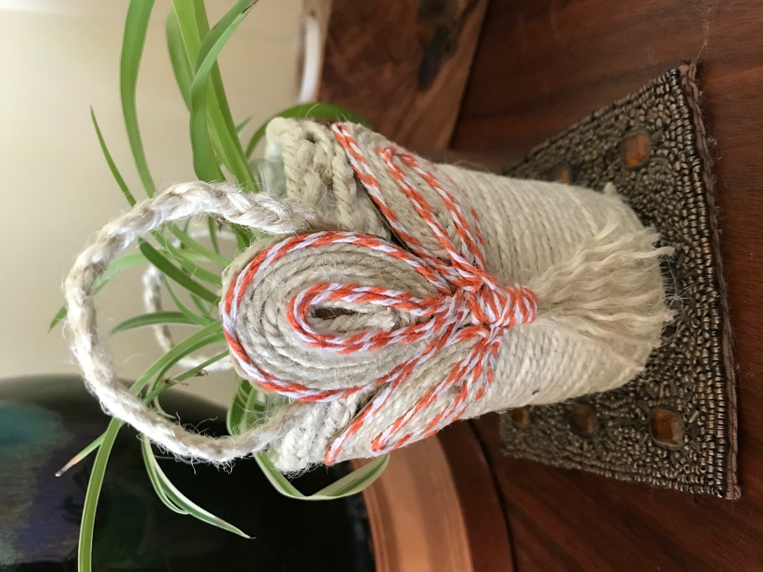
In your kits:

Can it hold catnip?
- Jute (rough textured cord)
- Baker’s twine (striped cord)
- Mod Podge glue
- Paper cup, rubber band, popsicle stick

You will need to provide:
Finished size: 3 ½” wide x 52/4” high. This basket is sitting on a coaster.
It’s tiny!

- Sharp Scissors
- Clips or clothespins
- Brown paper (shopping bag)
- Pencil

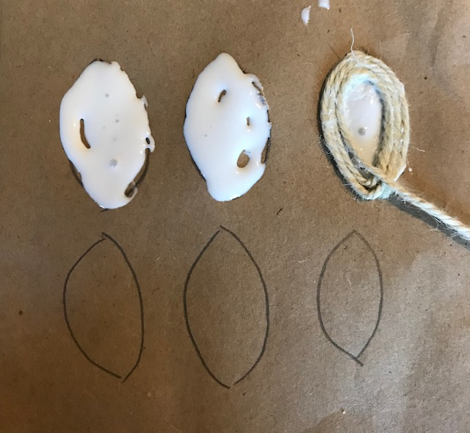
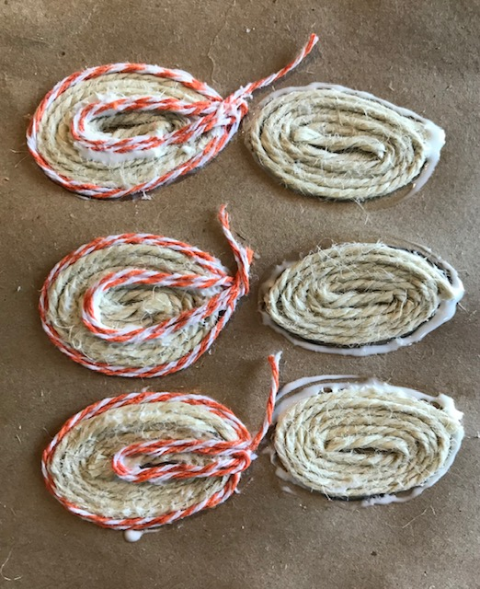
Starting with the petals
Prepare your cord & twine for the 6 petals first. The jute is the heavy brown cord. The Baker’s Twine is the striped cord.
Jute: 6 lengths of 18”.
Baker’s Twine: 6 lengths of 16”
Start with a clean, unwrinkled brown paper bag and cut a rough 12” x 12” piece.
Draw 6 leaf/petal shapes. They don’t have to be an exact match. They should be roughly
2” x 1 1/8”. Fill in 3 leaves with glue.

Wrap the brown jute around the petal shape. Start from the outside. After you have done 3 petals, put in the glue for the rest of the petals.
Using the stick or your fingers, put glue around the outer edge and inner part like the picture here. Then, on top of the jute, wrap the Baker’s twine around the outer edge 2x and then 2x in the center as in the picture. Set them aside to dry while you start the next step-wrapping the cup.

Now for the cup/basket
Spread 1" of glue around the top or bottom of the cup. Smoosh it around with your finger or the popsicle stick. It should be thick. Start wrapping the jute around the edge and work your way around until the whole cup is covered. Push the jute down a little as you go along so that there are no gaps. Smooth down the ends with a little extra glue. When the full cup is covered set it aside.
Cut out the petals.
Tip: Wrap them gently around a pencil so that they are a little rounded. This will give them some dimension. Set them aside.

Preparing the jute braid trim:
- Measure out 3 strands of 30” lengths for the handles.
- Measure out 3 strands of 11” lengths for the rim of the cup.
- Measure out 3 strands of 25” lengths for wrapping over the handles.

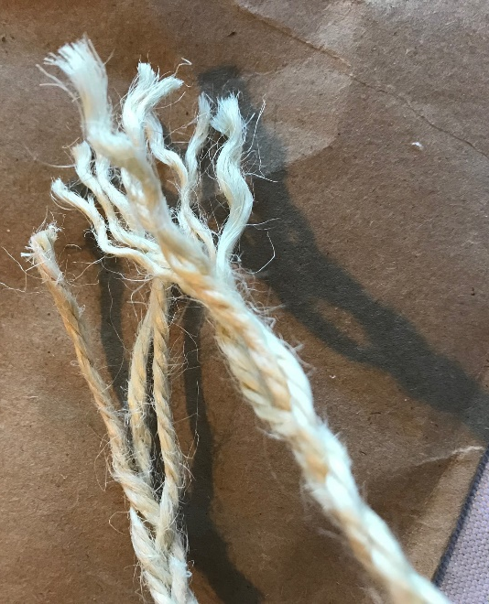
Tip: I found it easiest to knot the end and tuck it into a drawer to do the braids. Braid A, B, and C. Leave each section with an inch to spare. You could also clip it down. Your braid will come out smoother if you have a little tension as you braid. Set C aside.

Cut A in half. Fray all of the ends by unraveling the jute. (Each cord was made of 3 cords.)

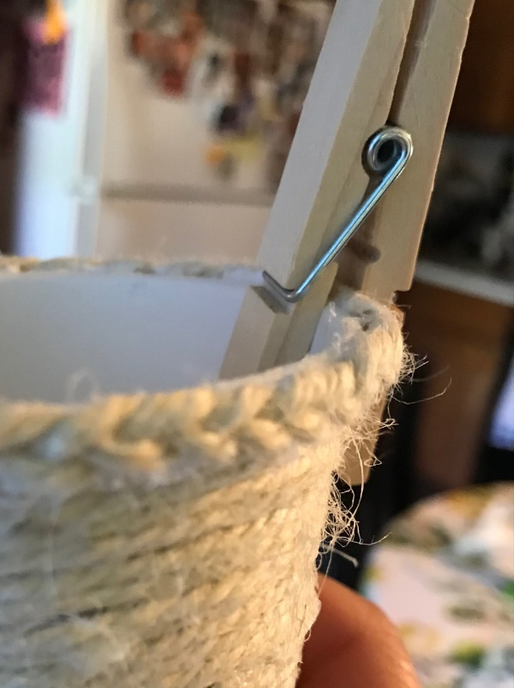
Braid B. Add a line of glue along the top rim of the cup and put the 11” braid around this rim. Trim the left-over ends and glue down. Use a clip or clothespin to hold the edges down while it dries. See picture.

Back to Braid A. Fold one of the braids in half. Take the Baker’s twine and wrap it 1 ½" from the end. See picture. It should be ½" to ¾" of wrapping. Glue down the ends. Set it aside. Repeat with the second braid.

Making the handles: Remove any clips. Put a thick line of glue on the back of each loop of braid and place one on each side of the basket. Glue here

Put the rubber band around the handles while they are drying in place.

Take Braid C and wrap it around the cup that it binds the loop handles to the basket. This braid should wrap around at least 2 times. Try to have it end or trim it near the handles. You won’t see it when the petals are attached.

Pick up the now dry petals and put plenty of glue on the backs. Glue one to the center of each handle. Add 2 to the sides. See the picture.
You can’t see it here, but Braid C is behind the petals.
It is holding down Braid A.

Wrap the rubber band around the cup and try to get it over all of the petals. Let it dry. Take off the rubber band and Tada! You have made a basket

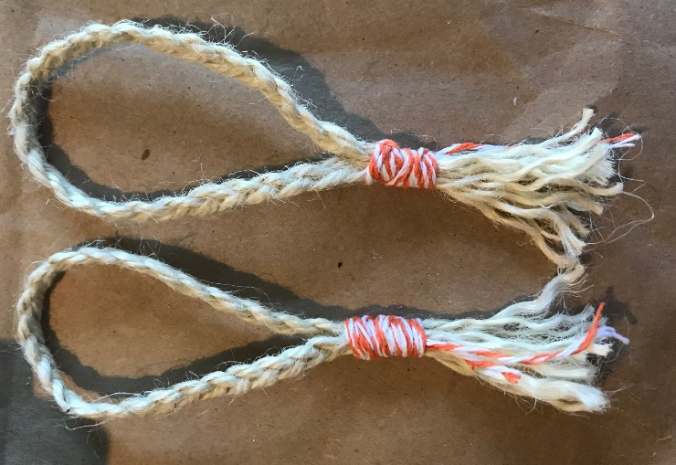
Thanks for crafting with me. Send questions to Jody at squadj@eglibrary.org

Is it a tiny scratching post?

